DISNEY KINDERGARTEN AND PRIMARY SCHOOL
P.2 ENGLISH

READ, COPY AND WRITE BOTH THE NOTES AND EXERCISES IN YOUR EXERISE BOOK PROVIDED BY YOUR PARENT. DO ONE LESSON EACH DAY.
THEME: OUR ENVIRONMENT
SUB THEME: Common animals and birds.
WEEK ONE
Lesson 1.
A composition about how you spent my holiday. (Narrative)
PRACTICE THIS LETTER IN YOUR EXERCISE BOOK
a a a a a a a

Lesson 2.
Spellings:
calf, kid, lamb, kitten, duckling, gosling, nestling, chick, bunny
Content: Vocabulary
cow, calf, duckling, sheep, piglet, cub, elephant, weaverbird, parrot, dove, monkey, eagle etc
Animals and their young ones:
Animal young one home
- cow _________ kraal/byre
- sheep lamb _______
- duck duckling _______
- lion cub ________
- cats ________ house
- pig piglet _________
- elephant calf _______
- hen ________ coop
- monkey baby __________
- rabbit _______ _________
- goat ________ shed
Exercise:
1. Fill in the missing letters.
a. el__ ph__nt d. fo__es__
b. c__l__ e. __ __glet
c. s__y f. d__ve
2. Match the animals to their young ones.
sheep cub
dog piglet
pig baby
lion puppy
monkey lamb
3. Re–arrange the letters correctly.
a. rbatbi - _______ d. tenkit - _____________
b. gdo - ________ e. keymon - __________
c. braze - ________ f. nahye _ ____________
4. Complete correctly
a. A __________ is a young one of a duck.
b. A young one of a horse is a _________.
c. A bird lives in a _________.
d. A ________ lives in a coop.

Activities
_ Reading and spelling the vocabulary
_ Matching animals to their young ones.
- Fill in the missing letters.
- Re-arrange the letters to form correct words.
- Construct sentences both orally and written.
Ref: MK Junior Literacy Bk2 pg 43 -52
St. Bernard English Thematic Pupil’s Bk2 pg 73 -84
Essential Work book 2 pgs 68 - 72

THEME: OUR ENVIRONMENT
SUB THEME: Common animals and birds.
LESSON 3.
LETTER PRACTICE
c c c c c c c

ANIMAL SOUNDS AND MOVEMENT:
spelling
neighs, hisses, bark, glides, crawling, slithers, roars, fry, stable
Content: animals sounds and their movement
Animal | Sound | Movement
dog | bark | _______________
horse | neighs | ________________
snake | ______________ | slithers
lion | roars | _____________
cow | moos/ lows | _______________
goat | ______________ | walks
duck | quack | ______________
monkey | _______________ | trees
sheep | bleats | __________________
donkey | brays | _______________
frog | croaks | water /land
cat | meows/ purrs | ________________
elephant | trumpets | ______________
cock | crows
fish | _________________ | swimming
(Children sing a song old MacDonald had a …………………………….…)
Exercise
1. Write the words correctly.
rdbi - ___________ stne - _____________ kcoc - _________
ffegira - _________ arkb - ____________ nihge - _________
2. Complete correctly.
- A bird __________________ .
- The young one of a monkey is a _______________ .
- A snake moves by ____________________ .
- Quack is to duck as _____________ is to dogs.
- Snakes hiss while monkeys _______________ .
3. Complete the riddles.
a. I have four legs. I live in a kennel.
My young one is a puppy. Who am I?
You are a ____________.

b. It slithers. Its young one is a snakelet. It lives in a hole.
What is it? It is a _________________.

4. Match correctly
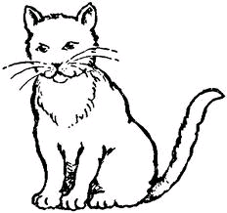
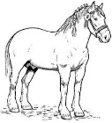
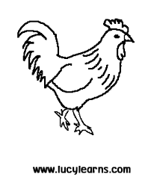
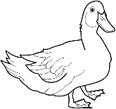
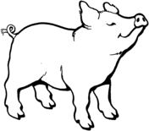

grunts

bleats

crows

quacks

purrs/meows

Activities.
- Reading and spelling the words
- Filling in the missing letters
- Re-arranging jumbled words correctly
- Completing puzzles
- Imitate/ role playing animal sounds and movements
-Matches pictures to sounds/movements
- Construct sentences orally and written using the vocabulary.
Ref: MK Junior Literacy Bk2 pg 43 -52
St. Bernard English Thematic Pupil’s Bk2 pg 73 -84
Essential Work book 2 pg 68 – 72

THEME: OUR ENVIRONMENT
SUB THEME: Common animals and birds.
LESSON 4:
e e e e e e

Spellings:
kept, domestic, environment, transport, wild, guard, money, tourist
COMPREHENSION. A passage about animals.
Read the passage and answer the questions in full sentences.
Animals.
In our environment we have two groups of animals. The domestic and wild animals. Domestic animals are kept in our homes and they include cows, goats, hens, cats, dogs and many others.

These animals are useful to us. Dogs guard our homes, cats chase rats in our houses, donkeys and horses are used for transport, cows provide us with milk, hens and ducks provide us with eggs and meat.

Wild animals are those found in bushes, forests and water bodies. Others are kept in zoos and game parks.
They include lions, crocodiles, antelopes, monkeys, snakes and many others. Wild animals are tourist attractions. The country gets money from the tourists. We also learn about these animals and some provide us with meat.

Questions
1. What is the passage about?
2. According to the passage, what are the two types of animals in our environment?
3. What are domestic animals?
4. How are dogs useful to people?
5. Apart from bushes and water bodies, where else do we find wild animals?
6. Write any two products got from these animals.
a) hens - b) goats -
7. What do we call people who go to look at wild animals at the Zoo or game parks?
8. Draw, name and colour any two wild animals.

Activities
- Reading and spelling the vocabulary and the passage
- Answering questions both orally and written.
- Role playing the animals mentioned in the passage.

THEME: OUR ENVIRONMENT
SUB THEME: Common animals and birds.
LESSON 5.
i i i i i i i i i

Spelling:
goat, cow, giraffe, fish, zebra, rabbit, duck, chicken, donkey, horse
Structures: What is this/ that? …. This/that is a / an…..
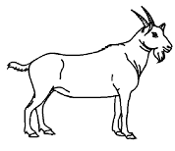
What is this?
1. This is a goat.
Is this a pig? No, it is not.

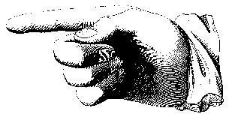
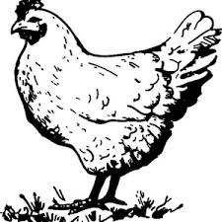
2. What is that?
That is a hen.
Is that a hen? Yes, it is.

Exercise
1. Complete correctly
a) What is this?
____________________________________

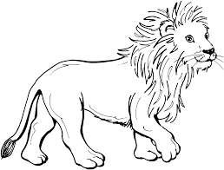
b) Is this a hen?
_____________________________________
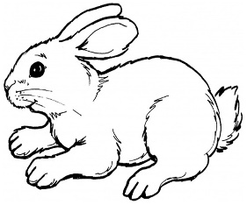
c) What is that?
_________________________________________

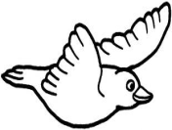

d) Is this an owl?
2. Underline the odd man out
a. weaver bird, elephant, monkey, lion
b) calf, piglet, dog, kitten
c) hawk, dove, cow, parrot, hen
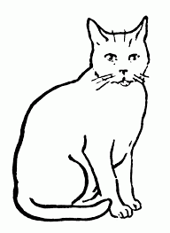
3. Make correct sentences using these words.
a) Giraffe -____________________________________________________________
b) zebra --____________________________________________________________
c) hyena --____________________________________________________________
4. Make small words from the big words.
a) sheep - __________ , ____________, ___________
b) goat - _________________, _______________
c) kitten - __________, _______________, __________
d) elephant - __________, _________
Activities
- Answering structural questions
- Reading, spelling and pronouncing words correctly
- Forming small words from big words
- Constructing sentences both orally and written
- Underlining the odd man out
Ref: MK Junior Literacy Bk2 pg 43 -52
St. Bernard English Thematic Pupil’s Bk2 pg 74 -76
Essential Work book 2 pg 68 – 72

WEEK 2
THEME: OUR ENVIRONMENT
SUBTHEME: Common animals and birds
LESSON 1:
b b b b b b b

Spellings:
puppies, calves, piglet, cubs, bunny, geese, snake, cheetah, ostrich

Plurals of animals
Singular (one) Plural (many)
cow cows
sheep sheep
fish fish
monkey monkeys
dog _________________
goat _________________
crocodile _________________
ostrich _________________
lion _________________
wolf _________________
tiger _________________
fox _________________
ox _________________
buffalo _________________
calf _________________
donkey _________________

(Children sing: One crocodile ……………………………..)
Exercise
Use the words in brackets correctly to complete the sentences.
- The farmer keeps four ___________ on his farm. (cow)
- There are many ______________ in the game park. (buffalo)
- Mr. Katogo has many _______________on his farm. (sheep)
- He used the _____________ to plough the garden. (ox)
- Our cow gave birth to two ___________ (calf)
- ________________ have long neck. (ostrich)
- _________________ are dangerous animals. (wolf)
- A dog has six __________________ . (puppy)
- ____________________ are poisonous animals. (snake)
10. I saw many _____________ at the zoo. (giraffe)
Activities
- Reading and spelling the words/ sentences correctly
- Changing different nouns to plural form.
- Constructing sentences using the words given.
Ref: MK Junior Literacy Bk2 pg 43 -52
St. Bernard English Thematic Pupil’s Bk2 pgs 77, 78,79,81,82
Essential Work book 2 pg 68 – 72

THEME: OUR ENVIRONMENT
SUBTHEME: Common animals and birds
LESSON 2:
o o o o o o

Spellings:
eagles, parrots, rabbits, geese, hawk, owl, antelope, lion, sparrow

Structures:
What are these/those? These/those are ………
Are these/those….? Yes, they are/ No, they are not.
1.
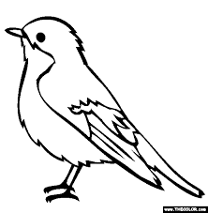
What are these?
These are sparrows.

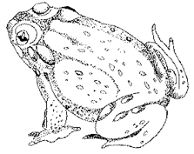
2. What are those?
Those are frogs.
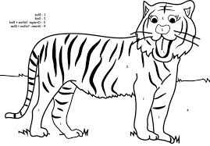
3. Are these dogs?
__________________________

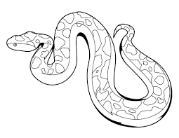
4. Are those snakes?
_____________________________
Exercise
- Fill in the missing letter.
- g_ _se b) ha__k c)p__ rr__ts d) ant__lo__e

2. Answer correctly.
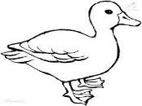
a.

What are these? ________________________________________
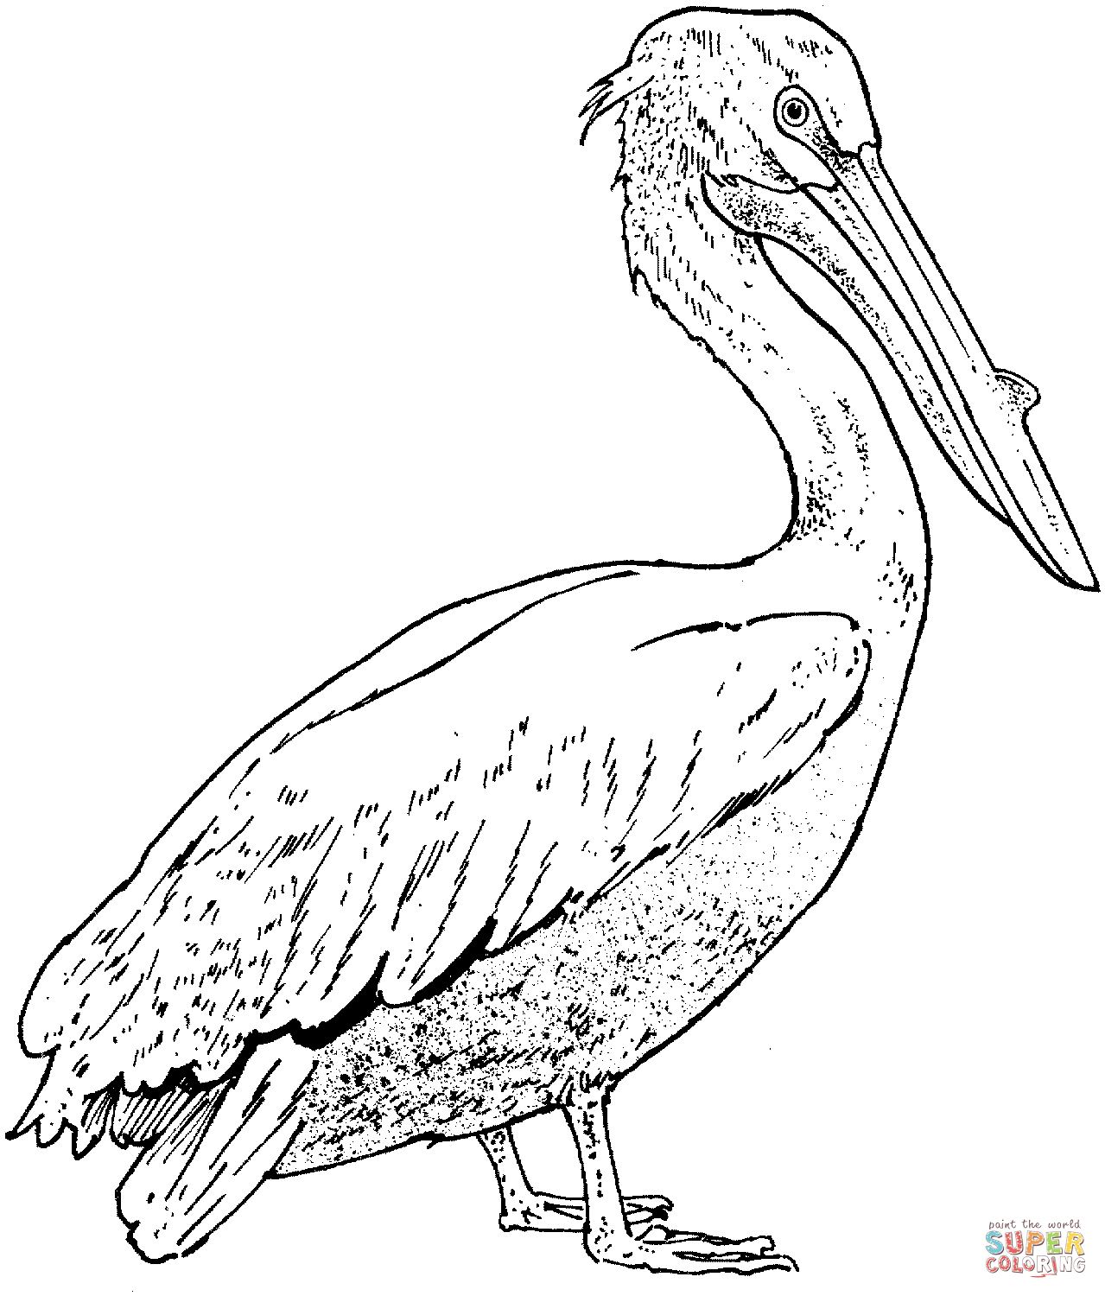

b. What are these? ___________________________________________


c. Are these tigers? __________________________
How many tigers can you see? _____________
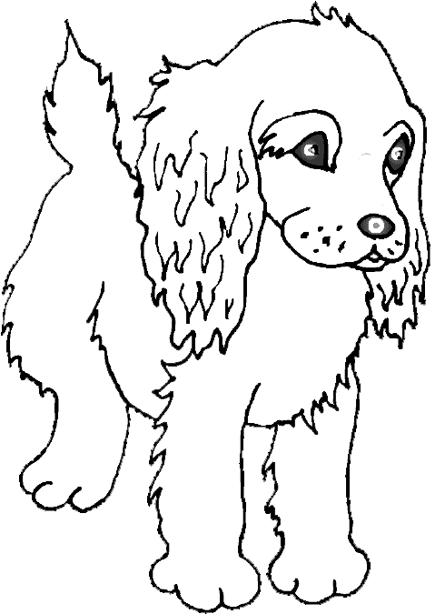
d. Are these calves? _______________________

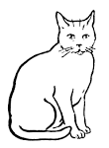
e.
Are these hens? ______________________

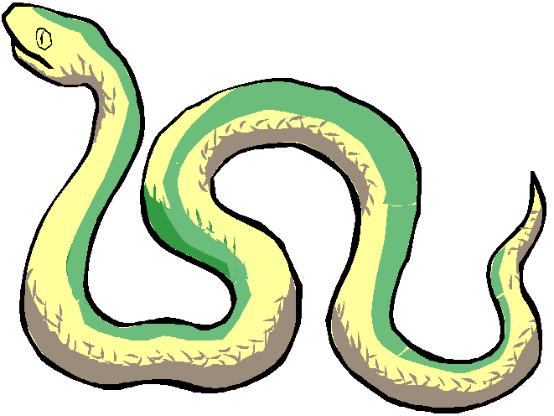
f.
Are these snakes? _______________________
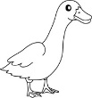
g.
Are these ducks? _________________________

- Re – arrange these letters correctly.
a) hkaw - _____ b) eglae -_____ c) atnepole -____
Activities
- Answering structural questions.
- Reading, spelling and pronouncing words correctly.
- Forming small words from big words.
- Constructing sentences both orally and written.
- Underlining the odd man out.
- Re–arrange jumbled letters.
Ref: MK Junior Literacy Bk2 pg 43 -52
St. Bernard English Thematic Pupil’s Bk2 pg 77 -79
Essential Work book 2 pg 68 – 72

THEME: OUR ENVIRONMENT
SUBTHEME: Common animals and birds
c c c c c

LESSON 3
Vocabulary: byre, stable, horses, kraal, cows, domestic, grass, hey, foals, calf, skin, transport,
Picture composition(description)
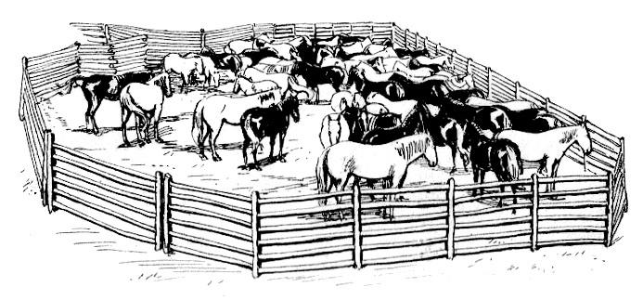

Pre-activities
1. Naming the animals in the picture orally.
2. Naming the young ones of the animal and where they live e.g. calf- kraal, chick- coop, foal- stable etc
3. Identifying whether they are wild or domestic animals.
4. Writing a composition.

Guided questions (Follow the guidelines below)
A. First paragraph
1. Which animals are shown in the picture?
2. Are they domestic or wild animals?
3. What do they feed on?

B. Second paragraph
3. What are the young ones of the above animals?
4. Where do they live?

C. Third paragraph
5. How are they useful to people?
6. What do we get from them?
Note: the composition should have a title and written in paragraphs. Each paragraph should have at least three lines.

Theme: Our environment
Sub-theme: common animals and birds
Lesson 4:
s s s s s s

spelling
chatters, hisses, bleats, whistles, buzzes, trumpets, brays, lows Content: Arranging sentences to form a good story.
Example
Arrange the sentences to form a correct story
- Daddy milks this cow every morning. (4)
- At home we have a bull and a cow. (1)
- A bull does not produce young ones. (2)
- And then takes the milk to the diary. (5)
- A cow produces young ones and gives milk. (3)

Activity
- One day, I visited my grandmother.
- The chick grew into a big hen.
- She gave me a chick to keep.
- The hen started laying eggs!

Activities
- Reading and pronouncing words/ sentences correctly
- Re–arranging jumbled sentences correctly

THEME: OUR ENVIRONMENT
SUBTHEME: Common animals and birds
Lesson 5
f f f f f f f

Spellings: eight, one, five, ten, fifteen, twenty, four, forty
Content: Number names
Examples
1 – one 8 – eight
2 – two 9 - nine
3 – three 10 - ten
4- four 11 - eleven
5 – five 12 - twelve
6 – six 13 - thirteen
7 - seven
Structures
How many --------can you see?
I can see -------------
1. How many birds can you see?
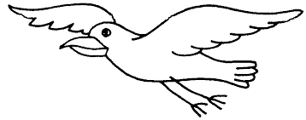

I can see five birds.
2. How many monkeys can you see?
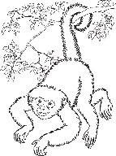

I can see seven monkeys.
Exercise
Do activity 10 in St Bernard English Thematic Pupil’s Bk 2 pg 82

